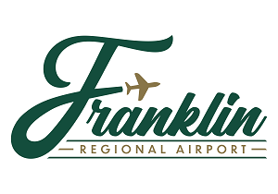

NOTICE TO THE PUBLIC
DISADVANTAGED BUSINESS ENTERPRISE (DBE) GOAL FOR
Franklin Regional Airport, Franklin VA

December 15, 2021

The City of Franklin, on behalf of the Franklin Regional Airport, hereby publishes a proposed overall goal for its Disadvantaged Business Enterprise (DBE) Program for federal fiscal years (FFY) 2020-2022. The proposed goal is 18.37% for all FAA-AIP funded projects in FFY 2020-2022. The methodology used in developing the goal is available for inspection during normal business hours at the office of the Airport Manager at the Franklin Regional Airport, 32470 John Beverly Rose Drive, Franklin, VA 23851. The City will receive and consider public comments on the proposed goal until January 14, 2022. Comments may be submitted in writing to:

Mr. Trevelyn Linton, Airport Manager
Franklin Regional Airport
32470 John Beverly Rose Drive
Franklin, Virginia 23851

Comments may also be submitted at tlinton@franklinva.com.

For additional information and questions, please contact Mr. Linton at (757) 562-8764 during normal business hours.

