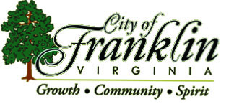
The Franklin Police Department would like to take this time to notify our citizens about several scams going on around the country due to the Covid-19 virus.

- There is a COVID-19 phone app that once downloaded locks your phone and demands bitcoins to unlock it.
- There are companies that are pushing their products saying they can cure COVID-19.
- There are phone scams that are taking reservations for COVID-19 testing.
- There are fake websites trying to get you to buy all the items that the country is short right now, masks, hand sanitizer and other items.
- There are fake charities popping yup allover trying to get you to donate to them.
- There are calls and emails from doctor's demanding payment to treat loved ones.

These are just a few of the scams out there, please verify if you choose to donate. Please research the information you are getting from a reputable source. If you know of or think that someone is trying to scam you, please call the Franklin Police Department, and also report them to the Federal Trade Commission, there website is FTC.gov.

Calls for Service:
- Whether for police or EMS our communications center will be asking a series of questions to determine the best way to provide services for the citizens of Franklin
Showing up at police headquarters:
- We will screen you with a series of questions to determine if we can allow you into the building.
- We have installed a phone outside of the building to allow citizens to make direct contact with our communications staff to assist them with their needs.
Animal Control:
- We will not be doing any adoptions until it is safe to do so.
- We will still return any stray animals that were picked up in the city.

Food Distribution
- Food distribution for school children will be located at S.P. Morton, Monday through Friday, from 1030 am until 12 noon. They will provide a lunch and a snack
- Grab and go food distribution will be located at the James L. Camp YMCA Friday 9:00 am to 11:00 am
Tuesday 5:30 pm to 7:30 pm

