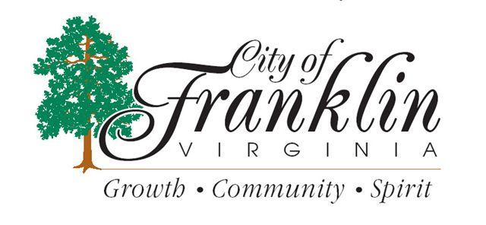
__________________
Memorial Park will be closed on
Saturday, July 31, 2021 due to maintenance.

In addition, Meadow Lane will be closed to thru traffic.
We apologize for any inconvenience this may cause.
___________________

