|  |
| --- |
| Regular City Council Meeting Minutes February 24, 2025 |

# Call to order

The Franklin City Council held its regular City Council meeting on February 24, 2025 at 7:00 p.m. in the City Council Chambers.

# Roll Call

Council Members in Attendance: Jessica Banks, Councilwoman; Wynndolyn Copeland, Vice-Mayor; Richard Grizzard, Councilman; Paul Kaplan, Mayor; Mark Kitchen, Councilman McLemore

Others in Attendance: Rosylen Oglesby, City Manager, Heather Lockerman, City Attorney

# Cell Phones

Mayor Kaplan asked all to silence cell phones.

# Pledge of Allegiance

The Pledge of Allegiance was recited by all in attendance.

Citizen’s Time

**Ms. Audrey Lee** made comments in reference to Mr. Felts and expressed concerns about the School System.

**Mrs. Carolyn Lawrence** made comments in reference to Mr. Felts and expressed concerns about the Superintendent.

**Ms. Carrie Johnson** made comments in reference to Mr. Felts and accountability of the Superintendent.

**Mr. Lamont Hill** made comments in reference to Mr. Felts and dissatisfaction with the Superintendent.

**Councilman Johnson joined the meeting at 7:12 p.m.**

**Mr. Don Spengeman** made comments in reference to Mr. Felts and expressed concerns about the School Board members and the Superintendent.

**Ms. Liz Burgess** expressed concerns about the growth and development of the community, issue regarding Mr. Felts, and School System accountability to Council.

**Ms. Brenda Peterson** made comments and expressed concern regarding the School System.

**Ms. Regina Hill** made comments in reference to Mr. Felts and the effects it has on the children.

Consent Agenda

A motion was made by Councilman Kitchen and seconded by Vice-Mayor Copeland to approve the consent agenda.

**The motion carried the vote 6-0**

**The vote was as follows:**

**Ayes: Banks, Copeland, Grizzard, Kaplan, Kitchen, McLemore**

**Abstained: Johnson**

# Presentations

The Electoral Board made presentations to city staff and elections staff.

# City Manager’s Report

Agenda Item #2025-16

A motion was made by Councilman Grizzard and seconded by Vice-Mayor Copeland to approve the Resolution Confirming a Declaration of Local Emergency Due to Severe Weather and the Threat of Winter Storm Kingston Impacting Franklin, Virginia.

**The motion carried the vote 7-0**

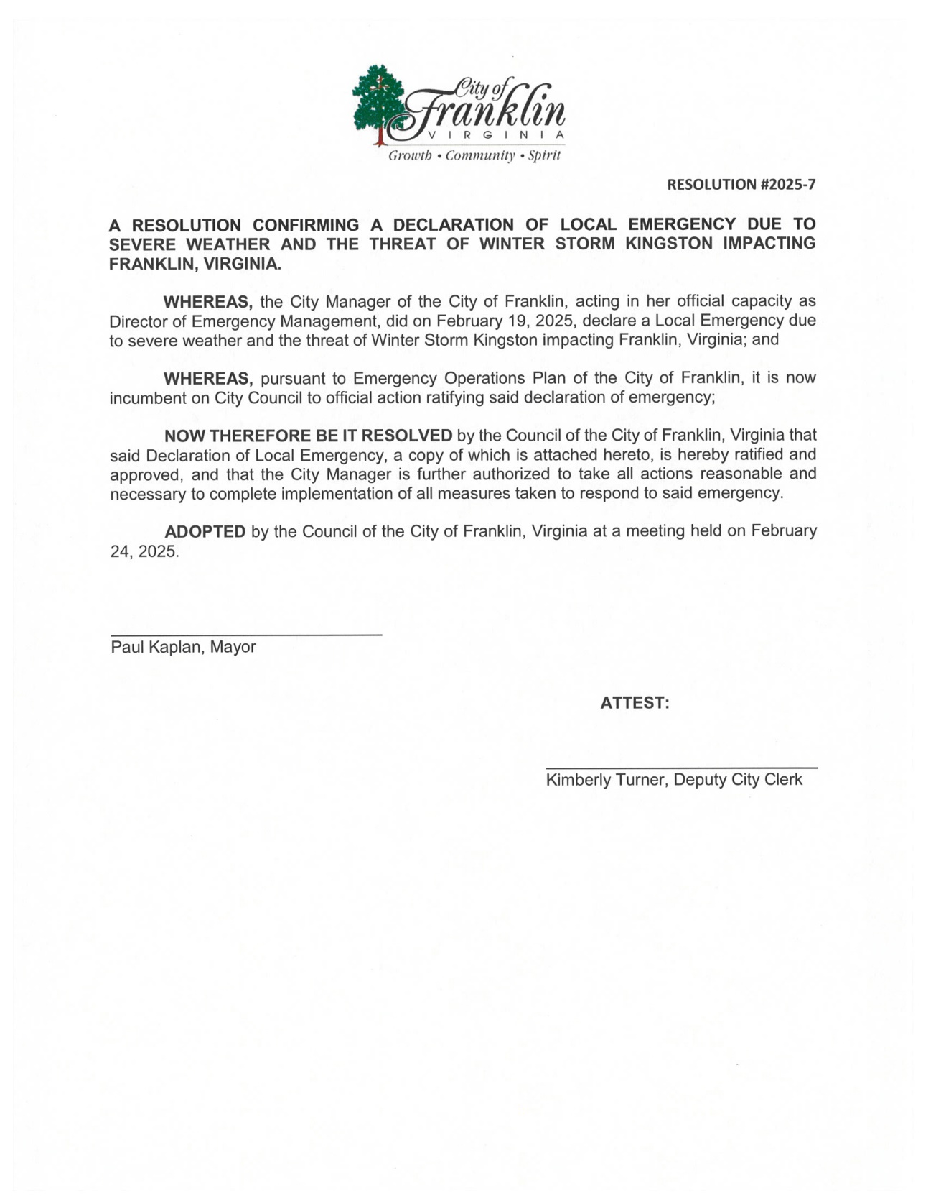**The vote was as follows:**

**Ayes: Banks, Copeland, Grizzard, Johnson, Kaplan, Kitchen, McLemore**

Agenda Item #2025-17

A motion was made by Councilman Kitchen and seconded by Vice-Mayor Copeland to adopt the Resolution Approving the Honorary Street Naming Policy.

**The motion carried the vote 6-1**

**The vote was as follows:**

**Ayes: Banks, Copeland, Grizzard, Johnson, Kaplan, Kitchen**

**Nays: McLemore**

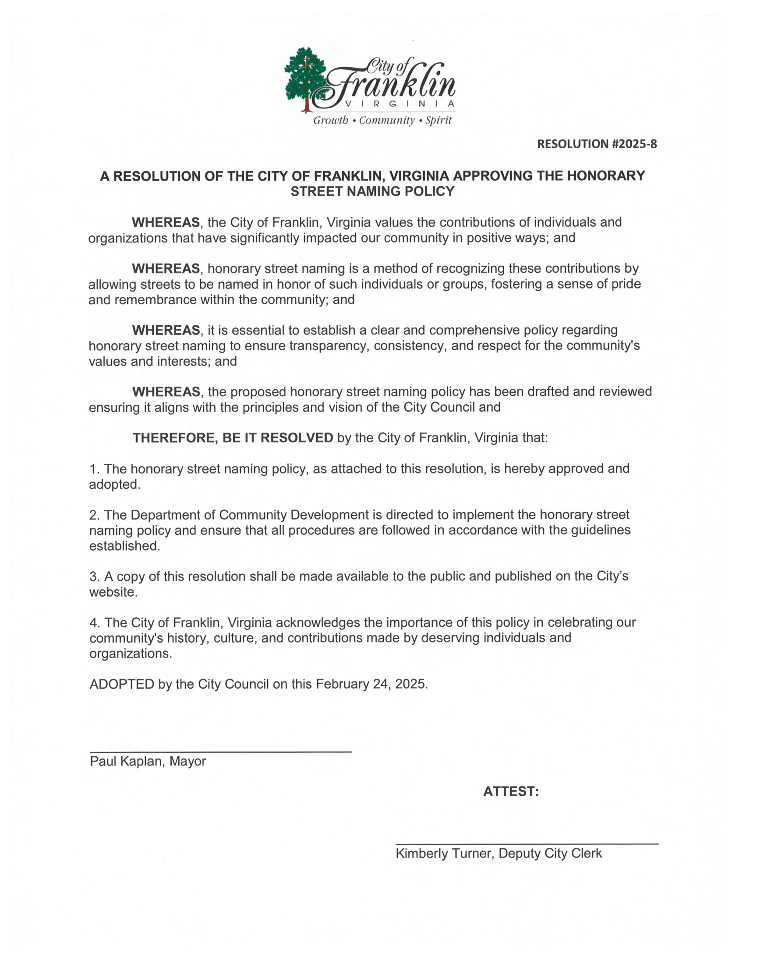

Agenda Item #2025-18

A motion was made by Councilman Kitchen and seconded by Councilman Grizzard to approve the Resolution Approving the Hay Cutting License Agreement Between the Franklin Municipal-John Beverly Rose Airport and Hash Family Farms of Suffolk.

**The motion carried the vote 7-0**

**The vote was as follows:**

**Ayes: Banks, Copeland, Grizzard, Johnson, Kaplan, Kitchen, McLemore**

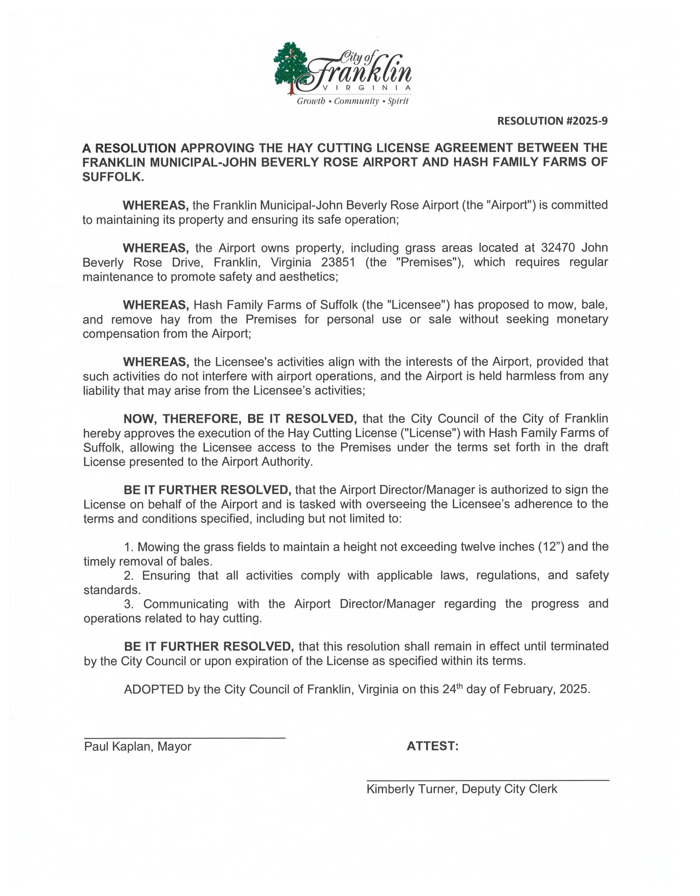

# New Business

1. Boards & Commissions

A motion was made by Councilman Johnson and seconded by Councilman Kitchen to appoint Mark Bly to the Virginia Municipal Electric Association.

**The motion carried the vote 6-1**

**The vote was as follows:**

**Ayes: Banks, Copeland, Grizzard, Johnson, Kaplan, Kitchen**

**Nays: McLemore**

B. Items Submitted by Council Members (Council Comments)

Vice-Mayor Copeland made comments regarding the proposed joint meeting with the School Board and the Mr. Felts issue.

Councilman Johnson thanked City Manager and staff for work they did during the winter storm in clearing roads.

Councilman Kitchen made comments in reference to the issue with Mr. Felts and the proposed joint meeting with the School Board.

Councilwoman Banks made comments in reference to the issue regarding Mr. Felts and proposed joint meeting with the School Board.

Councilman McLemore made comments in reference to the School Board and the Superintendent violating laws. Councilman McLemore also made comments in reference to changing street names instead of honorary street naming.

Councilwoman Banks made comments in reference to support of street naming, but with polling residents and businesses on that street.

Councilman Grizzard made comments in reference to the issue regarding Mr. Felts and accountability from the School System.

Mayor Kaplan informed the Board that they received a thank you note from Ms. Burgess, he thanked the Electoral Board and welcomed the general Registrar. Mayor Kaplan also made comments in support of Mr. Felts and acknowledged a letter from Becky Gillette, a former educator.

Council made further comments referencing the School System and the issue regarding Mr. Felts.

City Manager Oglesby clarified how rates are set.

Closed Session

A motion was made by Councilman Grizzard and seconded by Councilman McLemore to convene a closed session pursuant to Virginia Code Section 2.2-3711 A-1, for the purpose of discussing, considering, or interviewing prospective candidates for employment.

**The motion carried the vote 7-0**

**The vote was as follows:**

**Ayes: Banks, Copeland, Grizzard, Johnson, Kaplan, Kitchen, McLemore**

Reconvene Regular Session

A motion was made by Councilman Grizzard and seconded by Councilman Johnson to reconvene open meeting.

**The motion carried the vote 7-0**

**The vote was as follows:**

**Ayes: Banks, Copeland, Grizzard, Johnson, Kaplan, Kitchen, McLemore**

Certification of Closed Meeting

Councilman Grizzard moved that each council member certify that, to the best of his or her knowledge: I hereby move that each council member certify that, to the best of his or her knowledge:

1. Only public business matters lawfully exempted from open meeting requirements under the Virginia Freedom of Information Act, and
2. Only such public business matters as were identified in the motion by which the closed meeting was convened were heard, discussed, or considered in the closed meeting just concluded.

Any member of the public body who believes that there was a departure from the requirements of clauses (i) and (ii), shall so state prior to the vote, indicating the substance of the departure that, in his or her judgement, has taken place. The statement shall be recorded in the minutes of the public body.

**City Council certified the meeting.**

**The motion carried the vote 7-0**

**The certification was as follows:**

**Certified: Banks, Copeland, Grizzard, Johnson, Kaplan, Kitchen, McLemore**

Adjournment

A motion was made by Vice-Mayor Copeland and seconded by Councilman Johnson to adjourn.

**The motion carried the vote 7-0**

**The vote was as follows:**

**Ayes: Banks, Copeland, Grizzard, Johnson, Kaplan, Kitchen, McLemore**

**The meeting adjourned at 9:06 p.m.**

Mayor Deputy Clerk to City Council