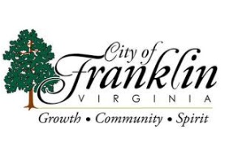**Franklin City Council Agenda**

**March 5, 2025**

**Council Chambers**

**207 West Second Avenue**

**Franklin, Virginia 23851**

**5:30 P.M.**

**Special Called Meeting**

**CALL TO ORDER.............................................................................VICE-MAYOR COPELAND**

**ROLL CALL.......................................................................................VICE-MAYOR COPELAND**

1. **APPROVAL OF AGENDA**
2. Approval of Special Called Meeting Agenda for March 5, 2025
3. **CLOSED SESSION**

Convene closed meeting for the following:

1. Pursuant to Virginia Code Section 2.2-3711 (A)(1) for the purpose of discussion, consideration, or interviews of prospective candidates for employment.
2. **RECONVENE REGULAR SESSION**
3. **CERTIFICATION OF CLOSED MEETING**
4. **ADJOURNMENT**