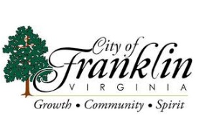**Franklin City Council Agenda**

**March 13, 2025**

**Franklin Municipal Airport**

**32470 John Beverly Rose Drive**

**Franklin, Virginia 23851**

**5:30 P.M.**

**Special Called Meeting**

**CALL TO ORDER................................................................................MAYOR PAUL KAPLAN**

**ROLL CALL..........................................................................................MAYOR PAUL KAPLAN**

1. **APPROVAL OF AGENDA**
2. Approval of Special Called Meeting Agenda for March 13, 2025
3. **CLOSED SESSION**

Convene closed meeting for the following:

1. Pursuant to Virginia Code Section 2.2-3711 (A)(1) for the purpose of discussion, consideration, or interviews of prospective candidates for employment.
2. **RECONVENE REGULAR SESSION**
3. **CERTIFICATION OF CLOSED MEETING**
4. **ADJOURNMENT**